What is a hypervisor?
A hypervisor or virtual machine monitor or VMM is a computer software, firmware or hardware that creates and runs virtual machines. A computer on which a hypervisor runs one or more virtual machines is called a host machine, and each virtual machine is called a guest machine. The hypervisor presents the guest operating systems with a virtual operating platform and manages the execution of the guest operating systems by virtually sharing its resources like memory and processing. Examples of hypervisor: VirtualBox, KVM, etc.

The term hypervisor is a variant of supervisor, a traditional term for the kernel of an operating system: the hypervisor is the supervisor of the supervisor, with hyper used as a stronger variant of super.
Generally, there are two types of hypervisors:
- Type 1 hypervisors, called “bare metal,” run directly on the host’s hardware.
- Type 2 hypervisors, called “hosted,” run as a software layer on an operating system, like other computer programs.

What is virtualization?
Virtualization is the process of creating a software-based, virtual version of something (compute storage, servers, application, etc.). These virtual versions or environments are created from a single physical hardware system. Virtualization lets you split one system into many different sections which act like separate, distinct individual systems. A software called Hypervisor makes this kind of splitting possible. The virtual environment created by the hypervisor is called Virtual Machine.

What is containerization?
Usually, in the software development process, code developed on one machine might not work perfectly fine on any other machine because of the dependencies. This problem was solved by the containerization concept. So basically, an application that is being developed and deployed is bundled and wrapped together with all its configuration files and dependencies. This bundle is called a container. Now when you wish to run the application on another system, the container is deployed which will give a bug-free environment as all the dependencies and libraries are wrapped together. Most famous containerization environments are Docker and Kubernetes. So, containerization is the process of bundling an application with all its dependencies.

Difference between virtualization and containerization
Containers provide an isolated environment for running the application. The entire user space is explicitly dedicated to the application. Any changes made inside the container is never reflected on the host or even other containers running on the same host. Containers are an abstraction of the application layer where each container is a different application.
Whereas in Virtualization, hypervisors provide an entire virtual machine to the guest(including Kernal). Virtual machines are an abstraction of the hardware layer where each VM is a physical machine.

What is Docker?
Docker is a containerization platform which packages your application and all its dependencies together in the form of containers so as to ensure that your application works seamlessly in any environment, be it development, test or production. Docker containers, wrap a piece of software in a complete filesystem that contains everything needed to run: code, runtime environment, system tools, system libraries, etc. It wraps basically anything that can be installed on a server. This guarantees that the software will always run the same, regardless of its environment.

What is a Docker Container?
Docker containers include the application and all of its dependencies. It shares the kernel with other containers, running as isolated processes in user space on the host operating system. Docker containers are not tied to any specific infrastructure: they run on any computer, on any infrastructure, and in any cloud. Docker containers are basically runtime instances of Docker images.

What are Docker Images?
Docker image is the template or blue print of Docker container. In other words, Docker images are used to create containers. When a user runs a Docker image, an instance of a container is created.

What is Docker Hub?
Docker images create docker containers. There has to be a registry where these docker images live. This registry is Docker Hub. Users can pick up images from Docker Hub and use them to create customized images and containers. Currently, the Docker Hub is the world’s largest public repository of image containers.

Explain Docker Architecture?
Docker Architecture consists of a Docker Engine which is a client-server application with three major components:
1. A server which is a type of long-running program called a daemon process (the docker command).
2. A REST API which specifies interfaces that programs can use to talk to the daemon and instruct it what to do.
3. A command line interface (CLI) client (the docker command).
4. The CLI uses the Docker REST API to control or interact with the Docker daemon through scripting or direct CLI commands. Many other Docker applications use the underlying API and CLI.

What is a Dockerfile?
A Dockerfile is a text document which contains all the commands that a user can call on the command line to assemble an image. So, Docker can build images automatically by reading the instructions from a Dockerfile.
You can use “docker build” command to create an automated build to execute several command-line instructions in succession.

Tell us something about Docker Compose.
Compose is a tool for defining and running multi-container Docker applications. With Compose, you use a YAML file (Docker Compose file) to configure your application’s services. Then, with a single command, you create and start all the services from your configuration.
Using Compose is basically a three-step process:
1. Define your app’s environment with a Dockerfile so it can be reproduced anywhere.
2. Define the services that make up your app in docker-compose.yml so they can be run together in an isolated environment.
3. Run docker-compose up and Compose starts and runs your entire app.
Compose has commands for managing the whole lifecycle of your application:
1. Start, stop, and rebuild services
2. View the status of running services
3. Stream the log output of running services

A docker-compose.yml looks like this:
version: '3'
services:
web:
build: .
ports:
- "5000:5000"
volumes:
- .:/code
- logvolume01:/var/log
links:
- redis
redis:
image: redis
volumes:
logvolume01: {}

What is Docker Swarm?
Docker Swarm is native clustering for Docker. It turns a pool of Docker hosts into a single, virtual Docker host.

Difference between Docker Compose and Docker Swarm
Docker Compose is a tool to define and run multi-container applications. Multi-container applications are applications where multiple containers work together to provide the required functionality. You define your application in the Compose file. You can run your application with the `docker-compose` command. The `docker-compose` command takes your Compose file as input and makes sure that your application’s state is what you described in the Compose file (we call this the desired state). Docker Compose can run your multi-container application on a SINGLE HOST ONLY, it cannot run your application on a computer cluster.
If you want to run your application on a COMPUTER CLUSTER, then you need Docker Swarm. Docker Swarm runs multi-container applications, just like Compose does. The key difference is that Swarm schedules and manages your containers across multiple machines, while Compose schedules and manages containers on a single host only.
You can use a standard Compose file to deploy your application to the Swarm. It’s the same Compose file that you use with Compose, but some options are limited to either Swarm or Compose in the Compose file.

What is the lifecycle of a Docker Container?
Docker containers have the following lifecycle:
- Create a container
- Run the container
- Pause the container(optional)
- Un-pause the container(optional)
- Start the container
- Stop the container
- Restart the container
- Kill the container
- Destroy the container

How to check for Docker Client and Docker Server version?
$ docker version

How do you get the number of containers running, paused and stopped?
$ docker info

If you vaguely remember the command and you’d like to confirm it, how will you get help on that particular command?
$ docker --help
$ docker <command> --help

How to login into docker repository means hub.docker.com?
$ docker login
You’ll be prompted for your username and password, insert those and congratulations, you’re logged in.
If you wish to use a base image and make modifications or personalize it, how do you do that?
You pull an image from docker hub onto your local system by using the following command:
$ docker pull <image_name>

How do you create a docker container from an image?
$ docker run -it -d <image_name>
-it is short for –interactive. When you docker run with this command, it would take you straight inside of the container.
-d means the container needs to start in the detached mode. Detached mode, shown by the option --detach or -d , means that a Docker container runs in the background of your terminal. It does not receive input or display output.

How do you list all the running containers?
$ docker ps
Suppose you have 3 containers running and out of these, you wish to access one of them. How do you access a running container?
The exec command lets you get inside a container and work with it:
$ docker exec -it <container id> bash

How to start, stop and kill a container?
$ docker start <container_id>
$ docker stop <container_id>
$ docker kill <container_id>

Can you use a container, edit it, and update it? Also, how do you make it a new and store it on the local system?
$ docker commit <conatainer id> <username/imagename>

Once you’ve worked with an image, how do you push it to docker hub?
$ docker push <username/image name>

How to delete a stopped container?
$ docker rm <container id>

How to delete an image from the local storage system?
$ docker rmi <image-id>

How to build a Dockerfile?
Once you’ve written a Dockerfile, you need to build it to create an image with those specifications. Use the following command to build a Dockerfile:
$ docker build <path to docker file>
$ sudo docker build . --tag=sccf_search

Some more points about Docker:
1. Docker containers are light weight alternatives of virtual machines.
2. Docker containers don’t have their own operating system. They sit on the top of the host operating system.
3. When we talk about run time, the docker containers have very less run time because you don’t need to boot the OS whereas in Virtual Machines, it has a runtime greater than the docker containers because you need to boot the OS.
4. In docker container, you don’t need to preallocate any RAM or any Disk space. It will take the RAM or Disk space according to the requirements of the application.
5. Docker solves the problem of not having a consistent computing environment throughout the software delivery lifecycle.
6. Docker images are nothing but the read-only templates that are used to create containers. These docker images contains all the dependencies for a particular application or a microservice.
7. Docker Containers are nothing but the runtime instance of docker image.
8. It is entirely possible that more than one image is required to create one container.
9. Docker Containers will have an application running in them and whatever the binaries and libraries required for that application is also packaged in the same container.
10. A developer writes a code that defines an application, requirements or the dependencies in an easy to write docker file and this docker file produces docker images. So whatever dependencies are required for a particular application is present inside the image.
11. The docker image is uploaded to the docker hub. Docker hub is the git repository for the docker images. It is basically a cloud hosted service provided by Docker.
12. We can use Jenkins servers or any continuous integration server to build an environment that contains all the dependencies for a particular application or a microservice. And that build environment is deployed on to various themes like testing, staging and production.

How to dockerize a spring-boot application?
Two techniques are there: one is using docker-maven plugin, and the other is by writing DockerFile.
Steps for docker-maven plugin technique:
1. Insert docker-maven plugin in the POM file.
<plugin>
<groupId>com.spotify</groupId>
<artifactId>docker-maven-plugin</artifactId>
<configuration>
<imageName>integration</imageName>
<baseImage>java:8</baseImage>
<entryPoint>["java", "-jar", "/${project.build.finalName}.jar"]</entryPoint>
<!-- copy the service's jar file from target into the root directory of the image -->
<resources>
<resource>
<targetPath>/</targetPath>
<directory>${project.build.directory}</directory>
<include>${project.build.finalName}.jar</include>
</resource>
</resources>
</configuration>
</plugin>
2. After adding this plugin, compile your code:
mvn clean install
3. Now run the docker build command as follows:
mvn docker:build
4. Now we can see a directory named “docker” inside the target directory. Inside this target directory, we can see the DockerFile. The content of the docker file will be as follows:
FROM java:8
ADD /hul-0.0.1-SNAPSHOT.jar //
ENTRYPOINT ["java", "-jar", "/hul-0.0.1-SNAPSHOT.jar"]
5. Now run the application with the docker as follows:
docker run -it -p host_machine_port:docker_container_port image_name
Run the following commands on three different terminals:
docker run -it -p 5001:5000 image_name
docker run -it -p 5002:5000 image_name
docker run -it -p 5003:5000 image_name
So now we have three instances of the same image running on the same machine which will serve at its 5001, 5002 and 5003 ports.
6. abc

Steps for writing docker file and then creating docker image (multi-stage docker image):
1. Create a docker file in the main repo of spring-boot application:
### BUILD image
FROM maven:3-jdk-11 as builder

# create app folder for sources
RUN mkdir -p /build
WORKDIR /build
COPY pom.xml /build

#Download all required dependencies into one layer
RUN mvn -B dependency:resolve dependency:resolve-plugins

#Copy source code
COPY src /build/src

# Build application
RUN mvn clean install
RUN ls -al /build/target/

### RUNTIME image
FROM openjdk:11-slim as runtime
EXPOSE 5000

#Set app home folder
ENV APP_HOME /app

#Possibility to set JVM options (https://www.oracle.com/technetwork/java/javase/tech/vmoptions-jsp-140102.html)
ENV JAVA_OPTS=""

#Create base app folder
RUN mkdir $APP_HOME

#Create folder to save configuration files
RUN mkdir $APP_HOME/config

#Create folder with application logs
RUN mkdir $APP_HOME/log
VOLUME $APP_HOME/log
VOLUME $APP_HOME/config
WORKDIR $APP_HOME

#Copy executable jar file from the builder image
COPY --from=builder /build/target/*.jar app.jar

#/usr/bin/java -jar -Dspring.profiles.active=icatqa2 -Xmx10g /opt/project-search/hulSearch-1.0-SNAPSHOT.jar
ENTRYPOINT [ "sh", "-c", "java $JAVA_OPTS -Dspring.profiles.active=local -jar app.jar" ]
2. After creating this file, run the following command:
sudo docker build . --tag=sccf_search
And the docker image will be created.

How to dockerize an angular application (multi-stage docker image):
1. Write following docker file in the base directory:
# base image
FROM node:10 as build
==> existing image from docker hub

# set working directory
WORKDIR /app
==> declare wworking directory

# add `/app/node_modules/.bin` to $PATH
# ENV PATH /app/node_modules/.bin:$PATH

# install and cache app dependencies
COPY . .
==> copied all files of the SCCF-WEB in the working directory of container
RUN ls -al
==> printing on console (can be ignored)
RUN npm install
==> installing node dependencies in container
RUN npm install -g @angular/cli@7.1.3
==> installing angular cli in container

# generate build
RUN ng build --configuration=PREPROD --output-hashing=all
==> building the project to create index.html, js and ss files in /app/dist/hul. This command will generate these deployment files in working directory of container.

# base image
FROM nginx:1.16.0-alpine
==> existing image of nginx from docker hub

# copy artifact build from the 'build environment'
COPY --from=build /app/dist/hul /usr/share/nginx/html
==> copied all files from previous container and stored in standard nginx directory that is /usr/share/nginx/html

# expose port 80
EXPOSE 80
==> exposing the nginx default 80 port to the 80 port of the host

# run nginx
CMD ["nginx", "-g", "daemon off;"]
==> command to run nginx in daemon mode

What is Kubernetes?
Kubernetes is an open-source container management tool which holds the responsibilities of container deployment, scaling & descaling of containers & load balancing. Being the Google’s brainchild, it offers excellent community and works brilliantly with all the cloud providers. So, we can say that Kubernetes is not a containerization platform, but it is a multi-container management solution.

Some good basic idea about Kubernetes:
11.50 to 35.30 of the following video:
https://www.youtube.com/watch?v=1xo-0gCVhTU

How is Kubernetes different from Docker Swarm?
Features | Kubernetes | Docker Swarm
Installation & Cluster Config | Setup is very complicated, but once installed cluster is robust. | Installation is very simple, but the cluster is not robust.
GUI | GUI is the Kubernetes Dashboard. | There is no GUI.
Scalability | Highly scalable and scales fast. | Highly scalable and scales 5x faster than Kubernetes.
Auto-scaling | Kubernetes can do auto-scaling. | Docker swarm cannot do auto-scaling.
Load Balancing | Manual intervention needed for load balancing traffic between different containers and pods. | Docker swarm does auto load balancing of traffic between containers in the cluster.
Rolling Updates & Rollbacks | Can deploy rolling updates and does automatic rollbacks. | Can deploy rolling updates, but not automatic rollback.
DATA Volumes | Can share storage volumes only with the other containers in the same pod. | Can share storage volumes with any other container.
Logging & Monitoring | In-built tools for logging and monitoring. | 3rd party tools like ELK stack should be used for logging and monitoring.

How is Kubernetes related to Docker?
Docker provides the lifecycle management of containers and a Docker image builds the runtime containers. But, since these individual containers have to communicate, Kubernetes is used. So, Docker builds the containers and these containers communicate with each other via Kubernetes. So, containers running on multiple hosts can be manually linked and orchestrated using Kubernetes.

What is the difference between deploying applications on hosts and containers?
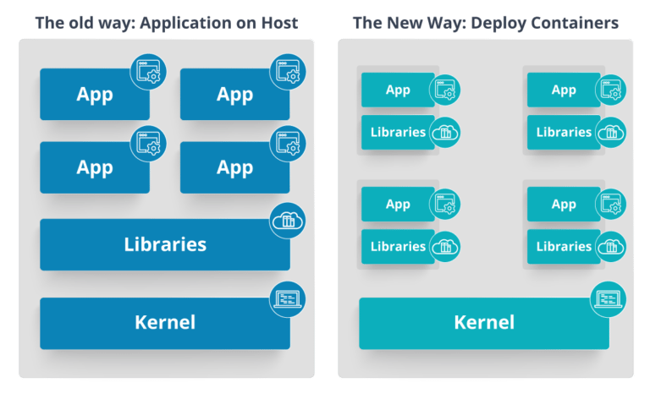

What is Container Orchestration?
Consider a scenario where you have 5-6 microservices for an application. Now, these microservices are put in individual containers, but won’t be able to communicate without container orchestration. So, as orchestration means the amalgamation of all instruments playing together in harmony in music, similarly container orchestration means all the services in individual containers working together to fulfill the needs of a single server.

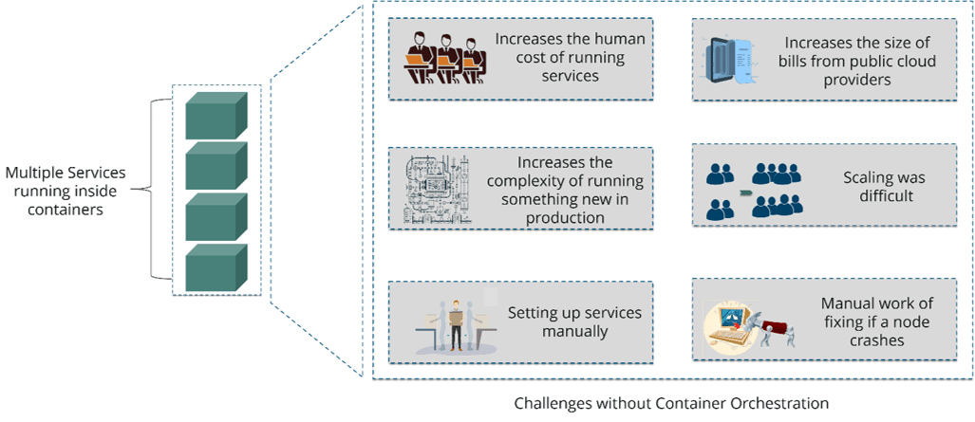
As you can see in the above diagram, there were also many challenges that came into place without the use of container orchestration. So, to overcome these challenges the container orchestration came into place.

What are the features of Kubernetes?
The features of Kubernetes are: Automated Scheduling, Self Healing Capabilities, Automated rollouts and rollback, Horizontal Scaling and Load Balancing,

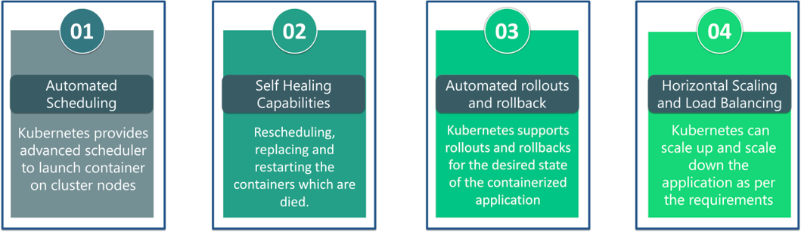
How does Kubernetes simplify containerized Deployment?
As, a typical application would have a cluster of containers running across multiple hosts, all these containers would need to talk to each other. So, to do this you need something big that would load balance, scale & monitor the containers. And Kubernetes is a good choice for this.

What is a kubernetes cluster?
A Kubernetes cluster is a set of node machines for running containerized applications. If you’re running Kubernetes, you’re running a cluster.
At a minimum, a cluster contains a worker node and a master node. The master node is responsible for maintaining the desired state of the cluster, such as which applications are running and which container images they use. Worker nodes actually run the applications and workloads.

What is Master in kubernetes?
The Kubernetes master refers to a collection of processes which is responsible for maintaining the desired state for your cluster. When you interact with Kubernetes, such as by using the kubectl command-line interface, you’re communicating with your cluster’s Kubernetes master. The “master” refers to a collection of processes managing the cluster state. Typically all these processes run on a single node in the cluster, and this node is also referred to as the master. The kubernetes master can also be replicated for availability and redundancy.

What is Node in kubernetes?
The nodes in a cluster are the machines (VMs, physical servers, etc) that run your applications and cloud workflows. The Kubernetes master controls each node; you’ll rarely interact with nodes directly.

What is Pod in kubernetes?
A Kubernetes pod is a group of containers that are deployed together on the same host. If you frequently deploy single containers, you can generally replace the word "pod" with "container" and accurately understand the concept. Pods operate at one level higher than individual containers because it's very common to have a group of containers work together to produce an artifact or process a set of work. Basically, a Pod is an atomic unit inside a Kubernetes cluster.

What is Deployment in kubernetes?
Kubernetes Deployment is an abstraction, how your application need to be deployed. A deployment’s fundamental purpose is to indicate how many pods are running at the same time. The deployment also manages the cluster if a pod fails in the process. The manual management of pods is eradicated when deployment is used. Basically, a Deployment is represented as an object in the cluster that represents a group of pods running, a logical group with some management capabilities tied to it. Deployments have semantics for the state of the cluster.

What is Service in kubernetes?
Service is really just a load balancer inside Kubernetes. When an application request is made it is passed to the application service, which knows what applications (pods) are available and how to send traffic to that application. Typically, the services send traffic in a round-robin manner, which means requests are spread across all the running applications (pods). A Service combines Pods and specifies how to access them (e.g. with a Service it is possible to expose your application outside the Kubernetes cluster). Because of a Service, your application will not be impacted when Pods suddenly terminate (a new Pod will automatically be created again). It is a kind of abstraction layer above Pods.

What is the difference between Deployment and Service in kubernetes?
Kubernetes Deployment is an abstraction, which tells you how your application need to be deployed. Deployments have semantics for the state of the cluster.
Kubernetes Service is an abstraction, which tells how to expose (make available) your application to outside world (to the networks, which your cluster connected to).

What is labels in kubernetes?
Labels are the mechanism you use to organize Kubernetes objects. A label is a key-value pair with certain restrictions concerning length and allowed values but without any pre-defined meaning. So you’re free to choose labels as you see fit, for example, to express environments such as ‘this pod is running in production’ or ownership, like ‘department X owns that pod’.
http://kubernetesbyexample.com/labels/

What is selector in kubernetes?
Labels do not provide uniqueness. In general, we can say many objects can carry the same labels. Selectors are the way to filter the objects on the basis of labels.
http://kubernetesbyexample.com/labels/

What is Minikube?
Minikube is a tool that makes it easy to run Kubernetes locally. This runs a single-node Kubernetes cluster inside a virtual machine.

What is Kubectl?
Kubectl is the platform using which you can pass commands to the cluster. So, it basically provides the CLI to run commands against the Kubernetes cluster with various ways to create and manage the Kubernetes component.

What is Kubelet?
Kubelet is an agent service which runs on each node and enables the slave to communicate with the master. So, Kubelet works on the description of containers provided to it in the PodSpec and makes sure that the containers described in the PodSpec are healthy and running.

What do you know about clusters in Kubernetes?
The fundamental behind Kubernetes is that we can enforce the desired state management, by which I mean that we can feed the cluster services of a specific configuration, and it will be up to the cluster services to go out and run that configuration in the infrastructure.

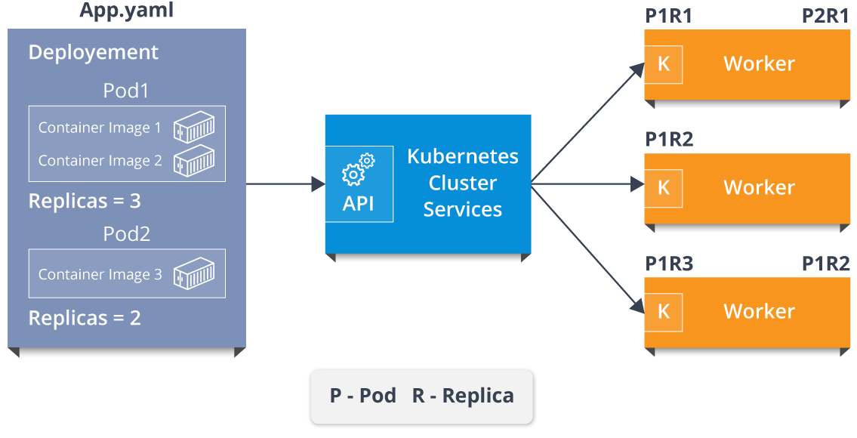
So, as you can see in the above diagram, the deployment file will have all the configurations required to be fed into the cluster services. Now, the deployment file will be fed to the API and then it will be up to the cluster services to figure out how to schedule these pods in the environment and make sure that the right number of pods are running. Example of an application.yaml:
---
kind: Service
apiVersion: v1
metadata:
name: integrationservice
spec:
selector:
app: integration
ports:
- protocol: "TCP"

# Port accessible inside cluster
port: 8080

# Port to forward to inside the pod
targetPort: 9999

# Port accessible outside cluster
nodePort: 30001
type: LoadBalancer

---
apiVersion: apps/v1
kind: Deployment
metadata:
name: integration
spec:
selector:
matchLabels:
app: integration
replicas: 5
template:
metadata:
labels:
app: integration
spec:
containers:
- name: integration
image: integration
ports:
- containerPort: 9999

So, the API which sits in front of services, the worker nodes & the Kubelet process that the nodes run, all together make up the Kubernetes Cluster.

What is a Heapster?
Heapster is a cluster-wide aggregator of data provided by Kubelet running on each node. This container management tool is supported natively on Kubernetes cluster and runs as a pod, just like any other pod in the cluster.

What are the different components of Kubernetes Architecture?

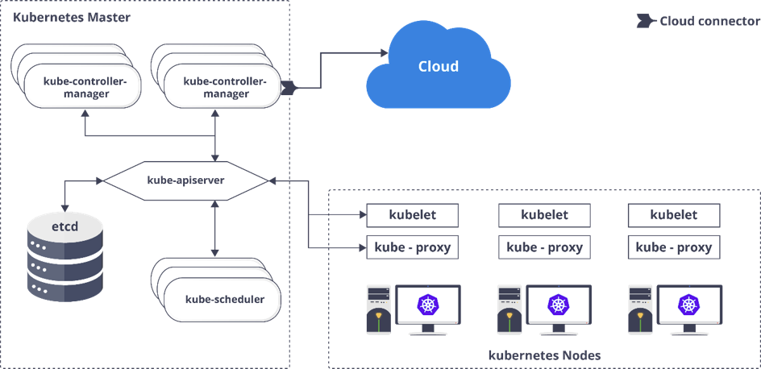
The Kubernetes Architecture has mainly 2 components – the master node and the worker node. As you can see in the above diagram, the master and the worker nodes have many inbuilt components within them. The master node has the kube-controller-manager, kube-apiserver, kube-scheduler, etcd. Whereas the worker node has kubelet and kube-proxy running on each node.

What do you understand by Kube-proxy?
Kube-proxy is a proxy service which runs on each node and helps in making services available to the external host. It helps in forwarding the request to correct containers and is capable of performing primitive load balancing. It makes sure that the networking environment is predictable and accessible and at the same time it is isolated as well.

Can you brief on the working of the master node in Kubernetes?
Kubernetes master controls the nodes and inside the nodes the containers are present. Now, these individual containers are contained inside pods and inside each pod, you can have a various number of containers based upon the configuration and requirements. So, if the pods have to be deployed, then they can either be deployed using user interface or command line interface. Then, these pods are scheduled on the nodes and based on the resource requirements, the pods are allocated to these nodes. The kube-apiserver makes sure that there is communication established between the Kubernetes node and the master components.
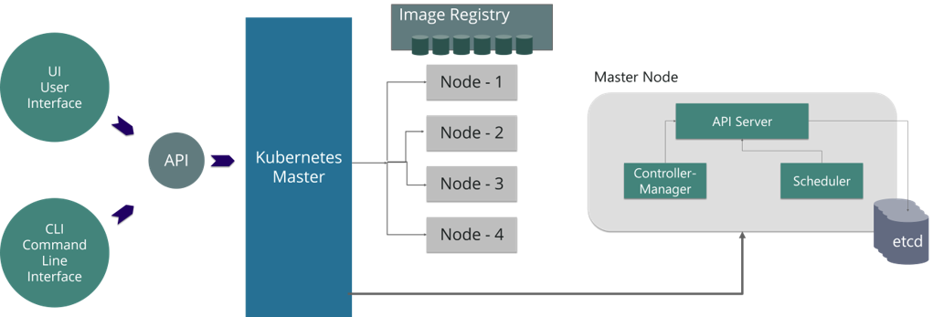

What is the role of kube-apiserver?
The kube – apiserver is the front-end of the master node control panel. This exposes all the APIs of the Kubernetes Master node components and is responsible for establishing communication between Kubernetes Node and the Kubernetes master components.

What is the role of kube-scheduler?
The kube-scheduler is responsible for distribution and management of workload on the worker nodes. So, it selects the most suitable node to run the unscheduled pod based on resource requirement and keeps a track of resource utilization. It makes sure that the workload is not scheduled on nodes which are already full.

Can you brief about the Kubernetes controller manager?
Multiple controller processes run on the master node but are compiled together to run as a single process which is the Kubernetes Controller Manager. So, Controller Manager is a daemon that embeds controllers and does namespace creation and garbage collection. It owns the responsibility and communicates with the API server to manage the end-points.

So, the different types of controller manager running on the master node are :
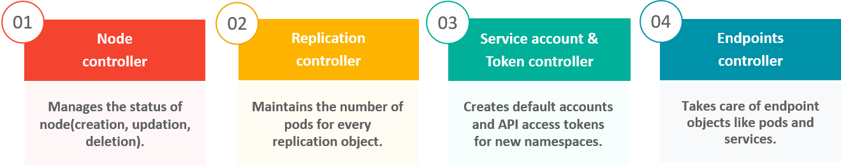
What is ETCD?
Etcd is written in Go programming language and is a distributed key-value store used for coordinating between distributed work. So, Etcd stores the configuration data of the Kubernetes cluster, representing the state of the cluster at any given point in time.

What do you understand by load balancer in Kubernetes?
A load balancer is one of the most common and standard ways of exposing service. There are two types of load balancer used based on the working environment i.e. either the Internal Load Balancer or the External Load Balancer. The Internal Load Balancer automatically balances load and allocates the pods with the required configuration whereas the External Load Balancer directs the traffic from the external load to the backend pods.

What is Container resource monitoring?
As for users, it is really important to understand the performance of the application and resource utilization at all the different abstraction layer, Kubernetes factored the management of the cluster by creating abstraction at different levels like container, pods, services and whole cluster. Now, each level can be monitored and this is nothing but Container resource monitoring. There are multiple tools for this. Heapster is one of them.

Service types in Kubernetes:
In Kubernetes, Service Types define how a service will be exposed inside and outside the Kubernetes Cluster. There are four types of service types in Kubernetes: ClusterIP, NodePort, LoadBalancer, ExternalName,

ClusterIP: Exposes the service on a cluster-internal IP address. Typically used for communication between different components of an application within the cluster.

NodePort: Exposes the service on each node's IP at a static port. Makes the service accessible externally using the node's IP and a specified port.

LoadBalancer: Creates an external load balancer (if supported by the cloud provider - supported by AWS, Azure, GC, etc.) to distribute traffic to service pods. Exposes the service externally, often used for applications that need to be accessed from outside the cluster. It provides external accessibility through the external IP of the load balancer.

ExternalName: Maps the service to the contents of the externalName field (e.g., a DNS name). Allows access to services outside the cluster by providing an alias. Accessible through the externalName (e.g., DNS name).

